SIMS & ASSOCIATES, INC.

[](https://www.housingfinance.com/)

**March 10, 2023**<https://www.housingfinance.com/developments/standard-communities-acquires-3-200-affordable-units_o>

**Standard Communities Acquires 3,200 Affordable Units**

***The national firm is expanding in the Southeast.***

Standard Communities has announced its largest acquisition, acquiring controlling interest in an affordable housing portfolio of nearly 3,200 units in Florida and Georgia.

The firm plans to invest nearly $25 million in capital improvements across the portfolio to benefit nearly 10,000 residents and ensure the communities remain affordable and resilient for years to come, announced company officials.

This portfolio marks Standard’s first acquisition in Florida and its first affordable acquisition in Georgia. With this transaction, the firm’s national portfolio has grown to nearly 19,000 units.

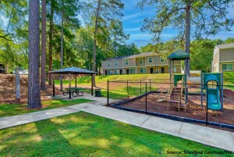*Standard Communities*

*With its latest acquisition, Standard Communities’ portfolio has grown to nearly 19,000 units.*

Officials declined to disclose the seller, a multistate owner of apartment communities, and the acquisition price.

“Standard is expanding its portfolio in the Southeast to foster more thriving communities in the region. We believe that when you invest in communities, you also invest in people’s futures by offering them a pathway to stability and prosperity,” said Jeffrey Jaeger, co-founder and principal of Standard Communities, which has headquarters in Los Angeles and New York.

Standard Communities has partnered with the nonprofit Apartment Life, whose on-site resident service coordinators work to increase residents’ access to education, foster community engagement, reduce food insecurity, improve health care access, and provide opportunities for economic mobility.

Apartment Management Consultants and Arco Management Corp. are responsible for property management services for the communities.

Also in Georgia, Standard broke ground on a project in Savannah last year that combines the renovation of an existing 1920s-era former Atlantic Coast Line Railroad office building and a new construction apartment building. The underutilized site will be transformed into a modern 219-unit market-rate community.